Git Guide: Brad Sherlock
Git init
[-b <branch-name> | --initial-branch=<branch-name>]
Git init creates an empty git repository or reinitializes an existing one. Branch name is where the name of the branch is inputted. If no name is given name will default to master/main.
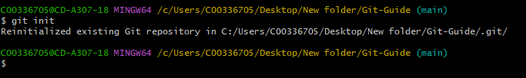
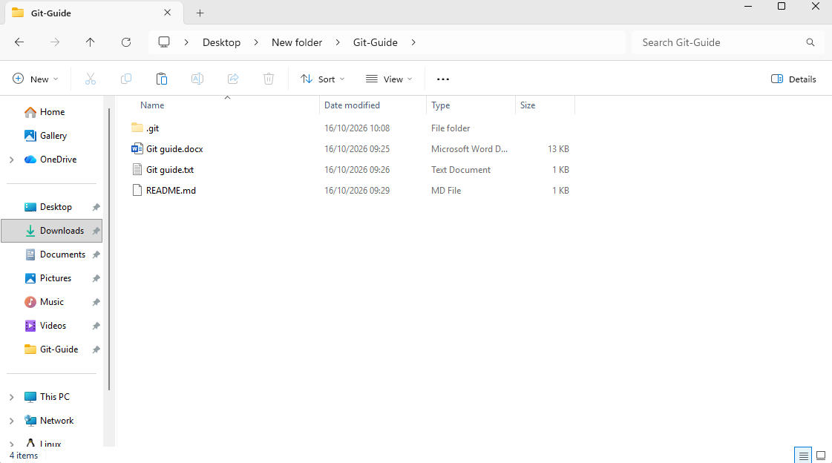
Git add
git add “File Name” (Exactly as saved)
Adds content from new or changed files to the index (or staging area). This is used to prepare for next commit.
Wrong
Right
Git status
Shows the working tree/working directory status. E.g. added files or modified files in working area.
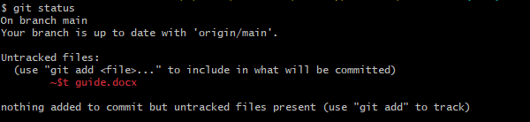
Git log
git log [<options>]
Lists all commits reachable by following the parent links from the given commit(s). Excludes commits reachable from the one(s) given with a ^ in front of them. Lists the items from most recent to oldest.
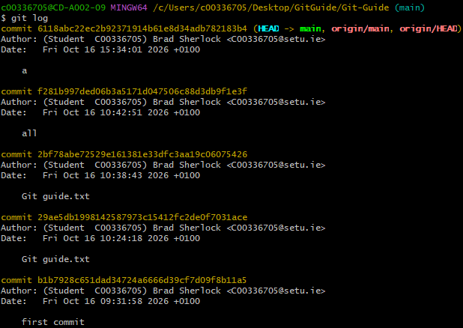

Git commit
git commit [-a | (all) / git commit -m “name” / git commit -am “name” (all and name)
Creates new commit containing current contents of the index and the given log message showing the changes. New commit is a direct child of HEAD, usually the tip of current branch, and the branch is updated to point to it.
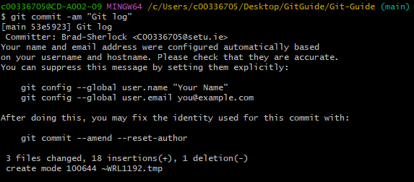
Git push
Git push -u origin main (first) / git push (all after first)
Updates one or more branches, nodes, etc in remote repository with information from local repository. Sends all necessary data that isn’t already on remote. Must use git push origin -u main for first push.
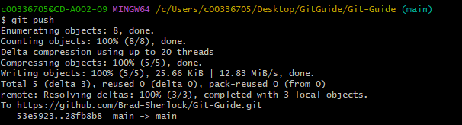
Git config
git config user.name “Name”/git config user.email “email”/git config--global core.editor notepad
git config is used to get and set global options or repositories. Can be used to set default name and email for commits and can be used to set windows notepad as default editor.
Git remote
Git remote –v/Git remote add <name> <url>/Git remote rm <name>
Manages set of repositories who’s branches you track. Can also be used to list, create and destroy remote repositories.
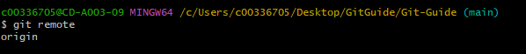
Git branch
Git branch new_branch_name / Git branch –a/-l/-r / Git ls-remote
Git branch lists, creates or delete branches. This includes creating new branches in local repositories, listing all branches in repositories and listing branches on remotes (including unknowns).

